Carol He

Protocol Script – immersive Viewpoint Transformation Task

Fall 2021

## Before participants arrive

### Initial Preparation

Follow the **Full VIVE Protocol’s Setup Protocol** to prepare the computer and VIVE devices.

* 1. Check participant’s info (initials, participant ID, and scheduled time) on the **participant log Google Spreadsheet (in RA Folder)**.
  2. Check participants’ order: Order 1: iVTT+SOT+Questionnaires; Order 2: SOT+iVTT+Questionnaires
  3. Prepare the debrief form to hand to the participants at the end.

### Task Preparation

1. Open the SteamVR application, click the 3 horizontal lines at the top left. Click into **Settings**. Under **Play Area**, change the **Activation Distance (m)** slider to **0.5** if it’s not already.

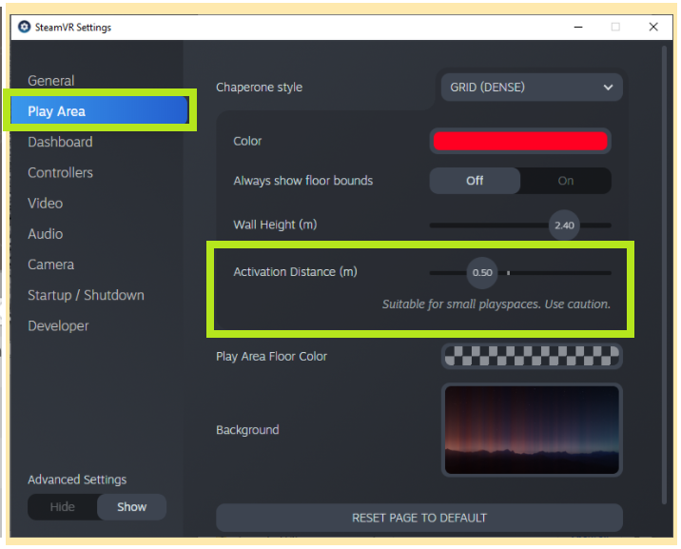

1. On the VR computer, open the folder with Unity apps in it. You don’t need to do anything with this yet.
2. On the no-VR computer, **open** the SOT task, instructions and questionnaires

## When participants arrive

### Welcome Participants

* + - * 1. **Before inviting them in, check that their initials match the name of the participant you are expecting.**
        2. Once you have confirmed that the correct participant is here, bring them into the room.

“Hello, welcome to the fourth session of this experiment. Thank you for being here. My name is _____. XX and I will be your experimenters today. You can leave your stuff on the ground or table there {if they have anything}. And if you have your phone with you, can you check that it’s on silent? We also recommend leaving your phone with the rest of your things.”

* + - * 1. Once they’re done: “Have a seat right here. We have hand sanitizer that you can use at any time *{Show them hand sanitizer}*.”

“Before we provide you the opportunity to calibrate in VR, please take a seat at the computer to read the instructions for the VR task of the session. Please read through the slides at your own pace. You can use the spacebar or the arrow keys to move between the slides. Let me know if you have any questions about the instructions.”

Answer any questions.

1. **Consent form + VR Introduction**
   * + - 1. “The first thing you see in front of you is an **informed consent sheet** that outlines your rights as a participant. Please read over this informed consent form carefully. Please ask me any questions before you sign and date it.”

Answer any questions.

Refer to **full** **VR Introduction Protocol.**

1. **Viewpoint Transformation Task**
   * + - 1. “Now we will begin the first VR task.”

*(Techie experimenter)* Click the **Viewpoint Transformation Task** icon in thefolder.

*(Techie experimenter)* Fill out the **Participant ID**. Click **Start** to start.

* + - * 1. “Before we begin, how is the volume? If it’s too loud or too quiet, we can adjust it for you.”
    1. **Make sure that the ear muffs are not only secure on the head but also leveled with the ears so that they can hear sound from the headset itself and not from the computer.**
    2. If they need to adjust the volume, say “You can access the sound settings from the same menu you used for the eye calibration. Click the menu button on your controller. Click the speaker icon on the bottom right with your trigger. Adjust the volume on the slider using the trigger. {pause} Once you’re done, you can exit the menu by clicking the menu button now your controller again.”

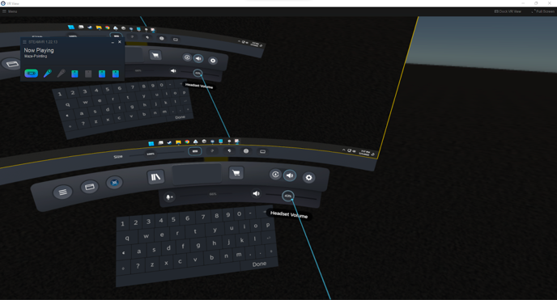

* + - * 1. “As a reminder, you need to use the trigger (where your index finger is) and the trackpad (where your thumb is) in this task. Remember to press the center of the trackpad when you’re using it. You may now put on the headset. Please go to the footprints and face the same direction of the footprints.”
        2. Practice trials:
    1. “Now you will have a chance to practice the task and get used to the headset. If you have any questions at any point, please ask me. Whenever you’re ready, please press the trackpad to start.”
    2. If the task is not advancing when they press the trackpad, they may need to move forward or backward a little to be right on the footprints. Tell them to keep the controller close to them and the headset. Also, they need to face forward. The text will indicate whether they’re ready to press the trackpad.

* + - * 1. Have them do the practice trials. Pay attention to how they did it to make sure they understand the task. These are some notes you can explain to them if you notice that their behavior is incorrect:
  1. “Please stand still before the map disappears.”
  2. “Please make sure your head is inside the red bubble/dots/sphere before you pull the trigger. We’re recording your location of the headset, not your controllers.”
  3. “Does the location of the red dot make sense to you./ Does it match what the map shows to you?”
  4. “Blue pointers are pointing to your current facing direction.”
  5. “Before we proceed to the testing trials, just to remind you, *imagine* that your facing direction is the same as the blue pointer direction.”
     + - 1. Make sure the participant understands the task after practicing.

“Do you have any questions before we start the task?”

Answer any questions.

1. Begin the test trials when ready:
   * 1. “Good, if you don’t have any questions, give me one second to set the task up for you.”
     2. *(Techie experimenter) Click the button on Unity to proceed to the testing trials.*

1. Pay attention to them to make sure they understand the task:
   * + 1. They should NOT step backwards to reach the target behind them. They must turn and move.
       2. They should NOT shuffle to the left/right to reach the left/right target. They must turn and move.
       3. They should NOT stretch out their arms during the map viewing phase and use that to indicate the direction for them.
       4. *(Techie experimenter)* When they have 10 trials remaining and are in an **empty environment**, say, “You have 10 trials remaining.”